**Change file date and Automatically delete previous file**

* Create an Empty File using touch

We use **stat** command to know our file details.

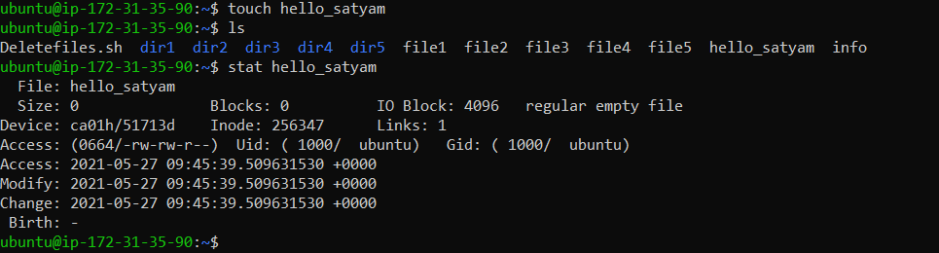

### Explicitly Setting Access and Modification time using -t and –d

* We can change the access time of a file using -a option. By default it will take the current system time and update the a time field.

Instead of taking the current time-stamp, you can explicitly specify the time using -t and -d options.

The format for specifying -t is [[CC]YY]MMDDhhmm[.SS]

$ touch -t [[CC]YY]MMDDhhmm[.SS]

$ touch -a -m -t 203801181205.09 hello_satyam

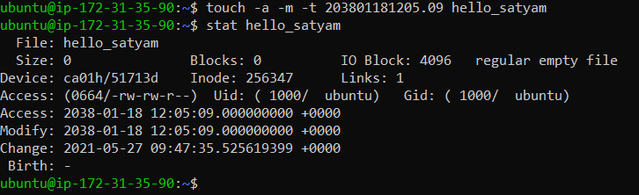

$ touch -t [[CC]YY]MMDDhhmm[.SS]

The following explains the above format:

* CC – Specifies the first two digits of the year
* YY – Specifies the last two digits of the year. If the value of the YY is between 70 and 99, the value of the CC digits is assumed to be 19. If the value of the YY is between 00 and 37, the value of the CC digits is assumed to be 20. It is not possible to set the date beyond January 18, 2038.
* MM – Specifies the month
* DD – Specifies the date
* hh – Specifies the hour
* mm – Specifies the minute
* SS – Specifies the seconds
* touch command help page

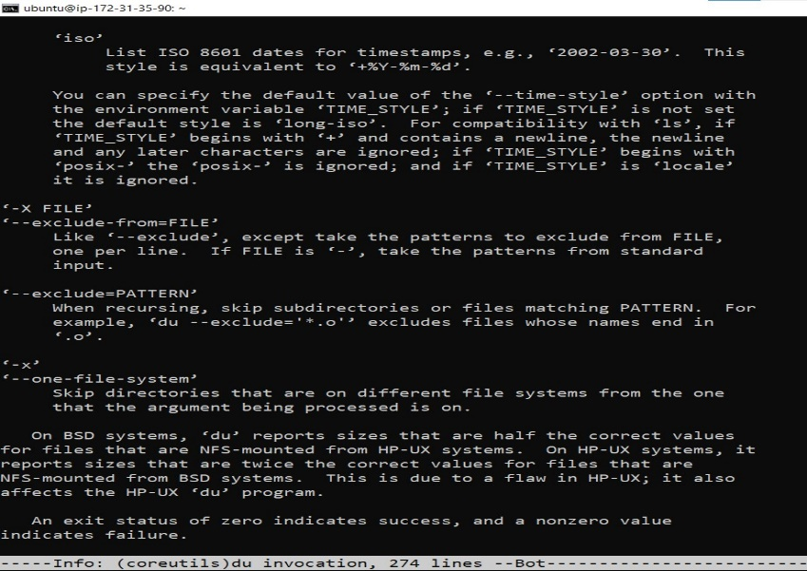

* 

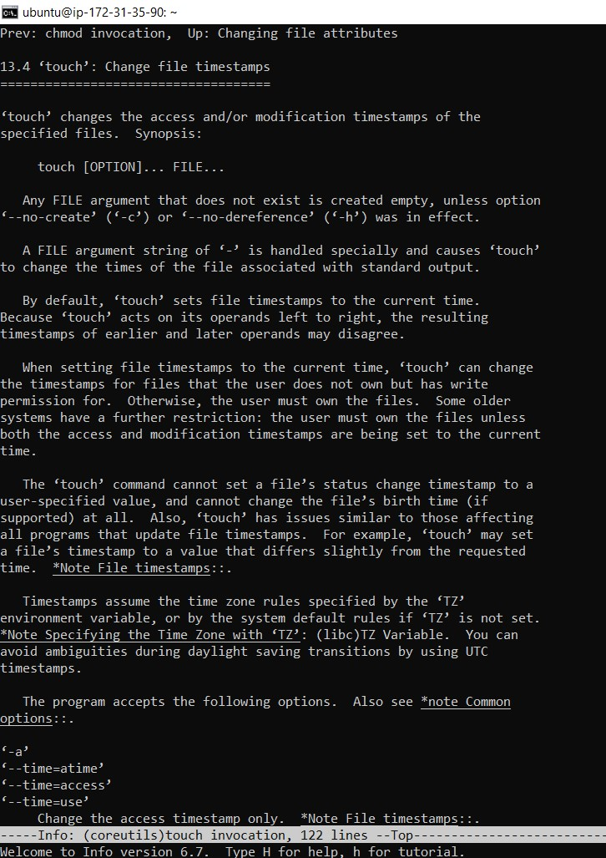

* **change system date**

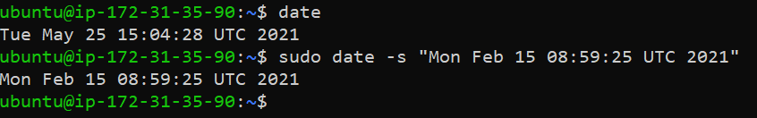

* **delete older file automatically script:-**

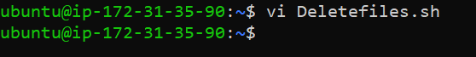

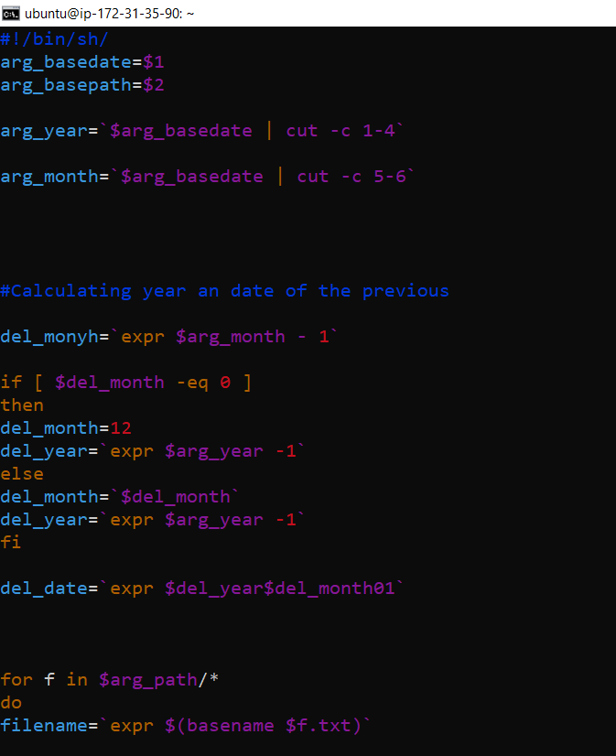

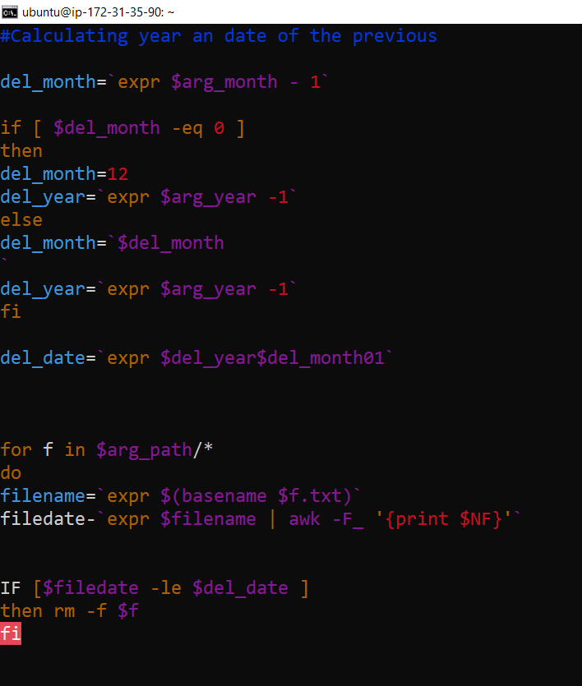

* **extract year and month**

